

**UNIVERSITY OF PETROLEUM AND ENERGY STUDIES**

**School of Computer** **Science**

**2020-21**

**GRAPHICS AND ANIMATION TOOLS LAB**

**Faculty: Dr. DURGANSH SHARMA**

**Assistant Professor**

**Department of Cybernetics.**

**School of Computer Science, UPES**

**Submitted By:**

**Name- Manushi Kapoor**

**Roll no-R100217037**

**Batch-B1**

**Semester- 7**

**Course-B.tech. CSE-OSOS**

**Sap Id- 500062100**

**EXPERIMENT NO 5**

**Aim** :- Design of 3D Text using Blender.

**Objective** :- To Design a 3D Text using features of Blender 2.8 .

**STEPS TO MAKE DESIGN A 3D TEXT:-**

1. Open Blender workspace and delete the existing cube.
2. Click on the add option and add text “Manushi”.
3. Then, set the depth of the text as 0.02 and extrude as 0.05. This will make our text 3D.
4. After making changes in the text, add the Bezier circle and adjust the Bezier circle around the text in such a manner that it surrounds the text
5. After the above step add the color to the text and add camera point on the boundary of the circle which is surrounded by the text

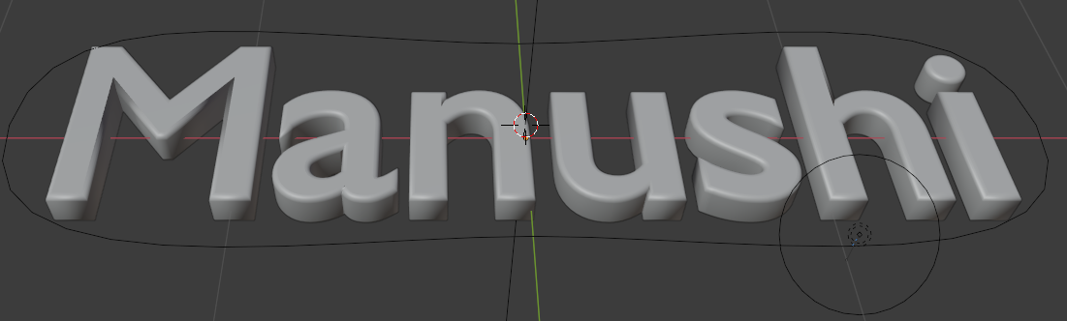

1. After the above step now we will add the metallic effect to the text and add the shading effect to the text and also we are going to change the color of the point to the color of your choice
2. Following are shown all the properties that are added to text.

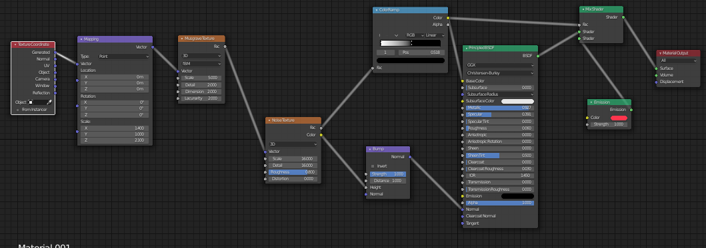

1. Make the background color darker so that light looks more attractive.
2. The final look of above steps is shown below –

